Create the following table and insert the necessary records to perform the following  
tasks.  
Employee Table:  
E_Number, E_name, E_basic_pay, E_HRA (10% of BP), E_DA (5% of HRA),  
E_Commission(2.5% of BP), E_Gross_Salary (sum of HRA, DA and Commission)  
     
create table Employee(E_Number number(3) PRIMARY KEY,  
E_Name varchar(20),  
E_Basic_Pay number(10),  
E_HRA number(10),  
E_DA number(10),  
E_Commission number(10),  
E_Gross_Salary number(10));  
insert into Employee(E_Number,E_Name,E_Basic_Pay) values(1,'Reeve',20000);  
insert into Employee(E_Number,E_Name,E_Basic_Pay) values(2,'Arjun',25000);  
insert into Employee(E_Number,E_Name,E_Basic_Pay) values(3,'Annmary',30000);  
insert into Employee(E_Number,E_Name,E_Basic_Pay) values(4,'Sona',35000);  
insert into Employee(E_Number,E_Name,E_Basic_Pay) values(5,'Snappy',40000);  
  
  
  
Q1. Write a PL/SQL function to calculate the HRA, DA, Commission and gross salary for a  
given employee.  
     
create or replace function hra(id number)return number  
as  
ehra Employee.E_HRA%type;  
ebp Employee.E_Basic_Pay%type;  
begin  
select E_Basic_Pay into ebp from Employee where E_Number=id;  
ehra:=ebp*0.1;  
return ehra;  
end;  
  
create or replace function da(hra number)return number  
as  
eda Employee.E_DA%type;  
begin  
eda:=hra*0.05;  
return eda;  
end;  
  
create or replace function commission(id number)return number  
as  
ecom Employee.E_Commission%type;  
ebp Employee.E_Basic_Pay%type;  
begin  
select E_Basic_Pay into ebp from Employee where E_Number=id;  
ecom:=ebp*0.025;  
return ecom;  
end;  
  
create or replace function gross(id number,hra number,da number,com number)return number  
as  
gross Employee.E_Gross_Salary%type;  
ebp Employee.E_Basic_Pay%type;  
begin  
select E_Basic_Pay into ebp from Employee where E_Number=id;  
gross:=ebp+hra+da+com;  
return gross;  
end;  
  
declare  
chra number;  
cda number;  
ccom number;  
cgross number;  
begin  
chra:=hra(1);  
cda:=da(chra);  
ccom:=commission(1);  
cgross:=gross(1,chra,cda,ccom);  
dbms_output.put_line('Reeve HRA='||chra||' DA='||cda||' Commission='||ccom||' Gross  
Salary='||cgross);  
End;

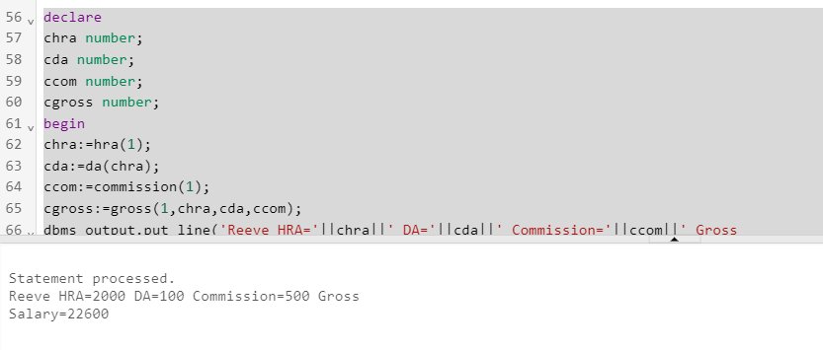  
   
  
Q2. Create a PL/SQL procedure block to update the all the components into the employee  
table retrieved from the above created function.  
     
create or replace procedure calculate is  
cnumber Employee.E_Number%type;  
cname Employee.E_Name%type;  
chra Employee.E_HRA%type;  
cda Employee.E_DA%type;  
ccom Employee.E_Commission%type;  
cgross Employee.E_Gross_Salary%type;  
cbp Employee.E_Basic_Pay%type;  
cursor cur1 is select*from Employee;  
begin  
open cur1;  
loop  
fetch cur1 into cnumber,cname,chra,cda,ccom,cgross,cbp;  
exit when cur1%notfound;  
chra:=hra(cnumber);  
cda:=da(chra);  
ccom:=commission(cnumber);  
cgross:=gross(cnumber,chra,cda,ccom);  
update Employee  
set E_HRA=chra,E_DA=cda,E_Commission=ccom,E_Gross_Salary=cgross  
where E_Number=cnumber;  
end loop;  
close cur1;  
end;  
execute calculate();  
select*from Employee;

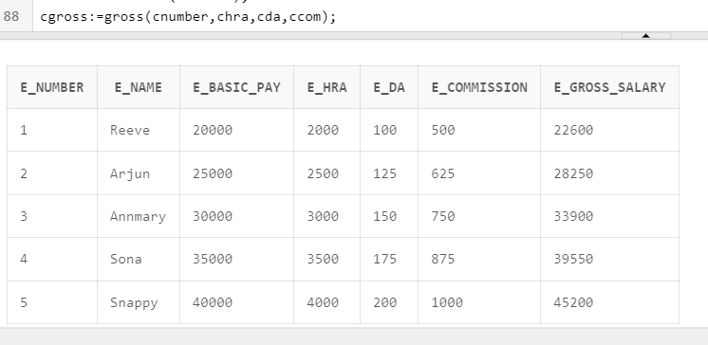  
  
   
  
Q3. Write a PL/SQL procedure using cursor to update the customer rating in the  
following  
schema based on their feedback as detailed below.  
Customer (Customer_id, Customer_name, Customer_feedback, Customer_Rating)  
Feedback Rating  
Excellent 5  
Very Good 4  
Good 3  
Satisfactory 2  
Bad 1  
No Feedback 0  
     
create table Customer(ID number(3) PRIMARY KEY,  
Name varchar(10),  
Feedback varchar(20),  
Rating number(3));  
insert into Customer(ID,Name,Feedback) values (1,'Reeve','Excellent');  
insert into Customer(ID,Name,Feedback) values (2,'Sona','Good');  
insert into Customer(ID,Name,Feedback) values (3,'Annmary','Very Good');  
insert into Customer(ID,Name,Feedback) values (4,'Snappy','Bad');  
insert into Customer(ID,Name,Feedback) values (5,'Guhan','Satisfactory');  
insert into Customer(ID,Name,Feedback) values (6,'Naina','No Feedback');  
create or replace procedure ratings is  
cid Customer.ID%type;  
cfeed Customer.Feedback%type;  
crating Customer.Rating%type;  
cursor cur1 is select ID,Feedback,Rating from Customer;  
begin  
open cur1;  
loop  
fetch cur1 into cid,cfeed,crating;  
exit when cur1%notfound;  
if cfeed='Excellent' then crating:=5;  
elsif cfeed='Very Good' then crating:=4;  
elsif cfeed='Good' then crating:=3;  
elsif cfeed='Satisfactory' then crating:=2;  
elsif cfeed='Bad' then crating:=1;  
else  
crating:=0;  
end if;  
update Customer  
set Rating=crating  
where ID=cid;  
end loop;  
close cur1;  
end;  
execute ratings();  
select*from Customer;

